Keck School of Medicine of USC
Beacon Accounts Receivable
Invoice Creation Manual

Getting Started

- To log in to Beacon, go to Beacon System Portal at https://beacon.usc.edu
- Click on “Accounts Receivable”
- Use your “med.usc.edu” credentials to login, not your USC ITS KFS/shibboleth login credentials.

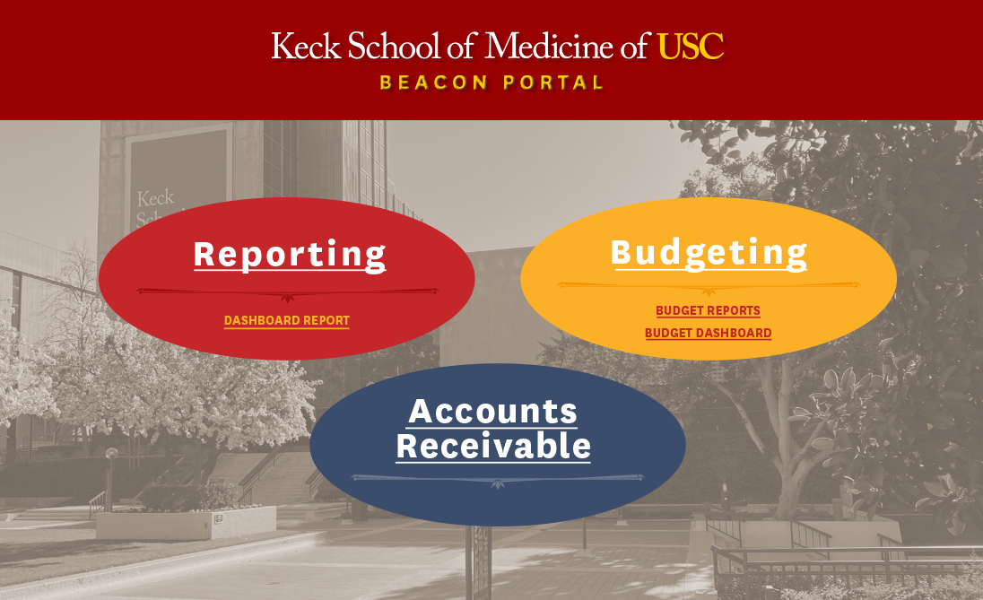

We recommend using Internet Explorer (full version, not Edge) or Google Chrome.

- Click on Please select a department, drill down to Clinical and click on your respective department:
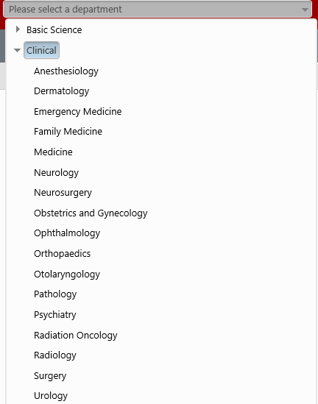
Create an Invoice

- Click on Create Invoice
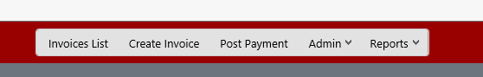

- Drill down on your Customer.
Invoice Date is the date you’re creating an invoice. It can be changed. Due date is fixed at
Net-30 but it can be changed too
Drill down on your Account Number

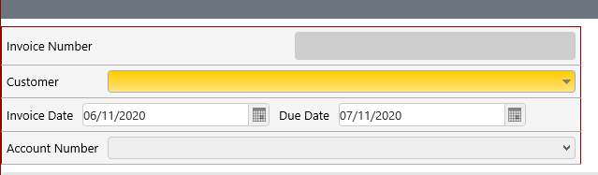

Note: If a Customer needs to be added, please email Angelica Chiang at caraig@med.usc.edu

- Click on Add New Row
Select Service Type, Add Description, Quantity and Unit Price
To add another row, click Add New Row
To remove a row while creating invoice, check the small box on the left of that row and click Remove Selected Row

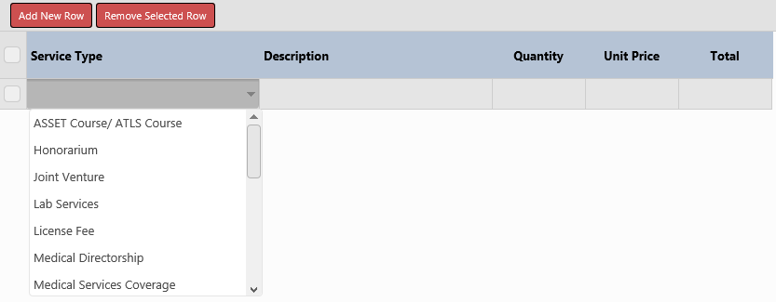

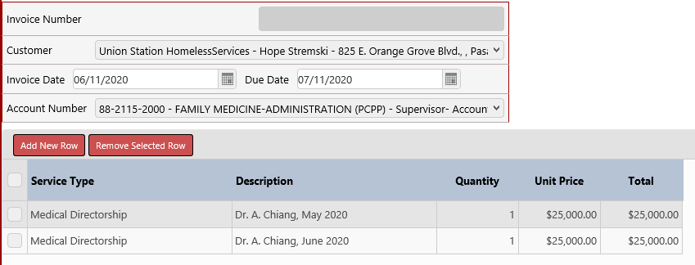

- Invoice number will be assigned when Save button or Submit button is clicked. Preview button will show Invoice in PDF Form regardless if an invoice was just Saved or already Submitted
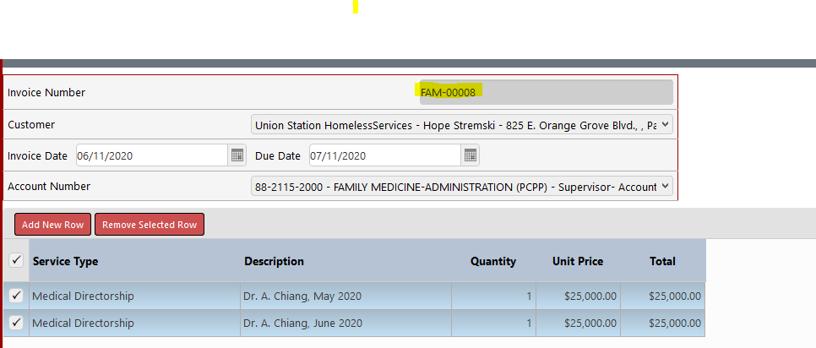

Note: Invoice can be corrected once Saved. Once Submitted and correction is needed, email Angelica Chiang at caraig@med.usc.edu for adjustment/correction request

Invoice List

- To view Saved invoice/s, go to Invoices List and click on Saved/Not Submitted button

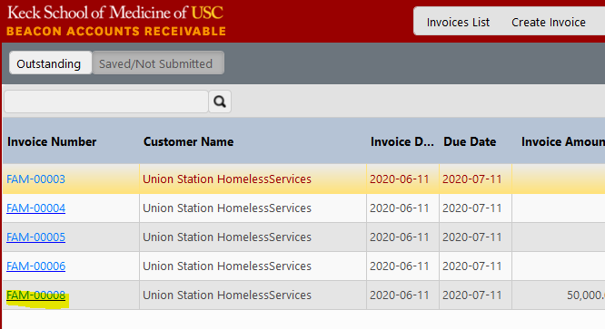

- To view Submitted invoice/s, click on Outstanding button
